Week In Review: Worlds Edition
Alex Shvartsman

WORLD CHAMPIONSHIP
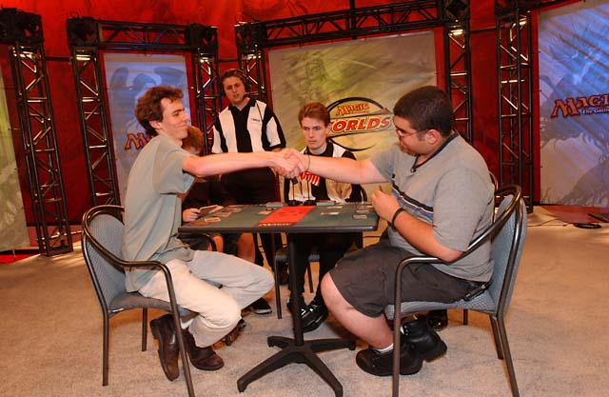
A week-long Magic extravaganza in Toronto, Canada signified the end of a very exciting pro season. As undoubtedly most of the readers of this column already know, The Netherlands national champion Tom Van de Logt defeated an American rookie Alex Borteh to become the 2001 Magic World Champion. A number of interesting storylines concluded, took place, or unfolded, during the tournament.
- For the first time ever, it looked as though the U.S. National team would not make it to the finals in order to defend the title. All three of its players had a poor Day 1, especially National Champion Trevor Blackwell, who went 0-6. Nevertheless, U.S. team members caught up over the next two days, and reasserted their dominance during the team day of competition, entering the finals in the lead. USA defeated Norway 2-1 to retain the team title for another year.
- Kai Budde easily hung on to his lead in the Player of the Year race. Having finished 44th at Worlds, he was guaranteed the title even before the Top 8 played it out - none of the players in the Top 8 could catch up to him even by winning the whole event and earning 32 points. Budde broke all records by finishing the season with 88 points.
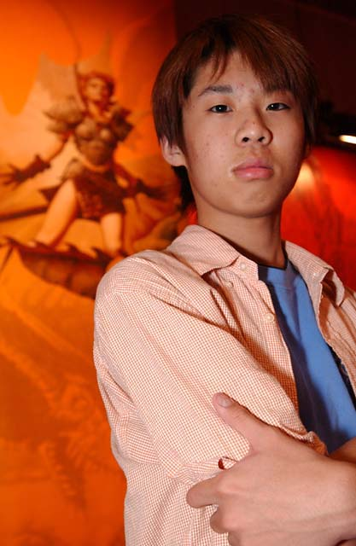
- It was an incredibly close race for the Rookie of the Year title. Top contenders were Americans Lawrence Creech and Ken Ho. Japanese Katsuhiro Mori entered Worlds as third in the race, several points behind. Throughout most of the tournament, Ho and Creech remained within a single match win of each other. Mori held pace, but he would need to outperform his opponents in order to close the gap. The race was decided on Friday, during the Extended competition, where Ho and Creech both fell behind as Mori posted a very impressive finish, coming in ninth overall in the tournament to earn 8 pro points and the Rookie of the Year title. Of interest is that 2000 Rookie Brian Davis earned his title over Thomas Preyer by also coming in 9th at Worlds last year.
- The latest in a series of disqualifications to rock the tournament scene, David Williams was ejected from the tournament during his Top 8 match. The judges felt that he was taking advantage of the fact that three Accumulated Knowledges in his deck were slightly bent. This is the highest-profile disqualification this season, exceeding that of Satoshi Nakamura at APACs. It prompted a lot of discussion at Worlds and on the internet with many of Williams's friends - such as Bob Maher Jr., Steve OMS, and Mike Flores, defending him. The DCI is sticking to its policy not to enter discussions or comment publicly on its decisions.
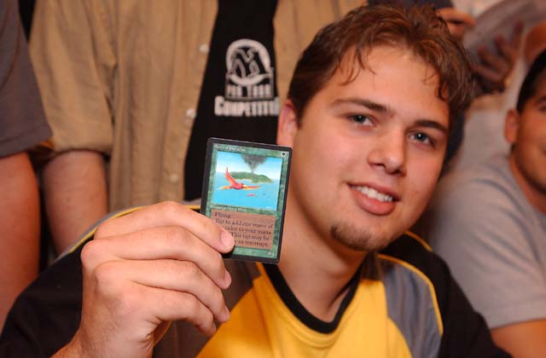
- For those not qualified, Worlds played host to a number of exciting side events. Among them were two IBC qualifiers, a Vintage draft, and a number of $800 tournaments (including Extended and Type 1). More details can be found on the Worlds coverage page here.

THE MAGIC INVITATIONAL
With the season over, it is time to hand out invitations to the most prestigious tournament of the year. Formerly known as Duelist Invitational, this exhibition tournament is the brainchild of Mark Rosewater. This year, 16 players will travel to South Africa - another first for Magic after holding an event in Australia last year. The players invited so far include:
Last year's Invitational winner Jon Finkel
World Champion Tom van de Logt
Invited on pro points: Kai Budde, Kamiel Cornelissen, Mike Pustilnik, Chris Benafel, Ryan Fuller, Zvi Mowshowitz, Antoine Ruel, Tsuyoshi Fujita, Scott Richards
The remaining five slots will go to the highest ranked DCI members in the World and four players invited based on the fan ballot. At the time this is being written, the voting is already over but the invitations have not been announced yet. Look for the complete list of the invitees on The Sideboard over the next few days.

GRAND PRIX-KOBE
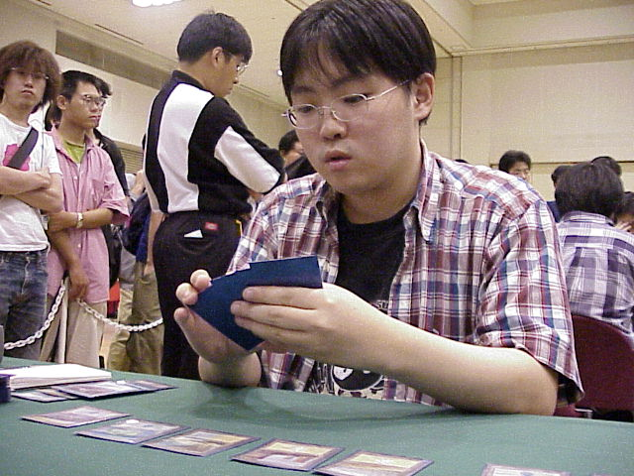
What better way to start a new Pro season than with a largest tournament in history? Grand Prix-Kobe had over 1300 players show up and compete. The staff deserves plenty of credit - despite such gargantuan numbers, Day 1 (9 rounds) was over by 10 pm, and Day 2 (7 rounds plus top 8) was over by about 9 pm. Some special rules applied to this tournament - since so many people showed up, the cut on Day 2 was to Top 128 rather than Top 64. This ensured that most players at the 7-2 record would get a chance to play on Sunday.
Itaru Ishida won the tournament with a creatureless u-r-w deck, similar to that played by Ben Seck at a qualifier at Worlds. Ishida is a true veteran as Japanese players go, and has been competing since the days of the Junior Pro Tour (he finished 21st in Dallas). Itaru's top Pro Tour finish was 13th at 1998 PT-LA. He enjoyed a number of Grand Prix Top 8s, including Manila, Taipei, and Tohoku. This is Ishida's first individual championship title.

GRAND PRIX-DENVER

Small in comparison, Denver gathered just over 400 competitors. If a well-known pro persevered in a field of 1300, a virtual unknown won in a much smaller field full of pro players. Brett Shears of California has two Pro Tours under his belt - in 1997 and 1998. His return to Magic is triumphant - Shears used Brian Kowal's b-g-u deck to dominate the field, defeating YMG's Danny Mandel in the finals. Other notables in the Top 8 included Darwin Kastle, Brock Parker, and Alex Borteh, who is fast becoming one of the hottest newcomers to the Pro scene.

COMING UP: GRAND PRIX-SANTIAGO
The first title tournament in Chile is about to take place this weekend. Although no one is expecting the kind of numbers seen at Kobe, it should be a swell tournament with many players expected to travel down from Argentina and Brazil. A number of Americans are going, too. Among those confirmed are Brian Davis and Alan Comer. Adrian Sullivan will be heading up Sideboard coverage at the event.

CHANGE OF VENUE
The 2001-02 season's European Pro Tour was scheduled to take place in Paris. The venue has changed. The new location will be Nice (please, hold the bad puns). The rest of the schedule remains unchanged. Pro Tour will visit New York, New Orleans, San Diego and Osaka, with World Championships in Sydney.

MAGIC TRIVIA
Last week's Question:
What promotional card was given out to participants and spectators at the 1999 World Championship in Yokohama, Japan?
A: Foil Balduvian Horde was given out at that tournament to players signing up for side events. Of course, each Worlds competitor also got one.
New question:
What card did Olle Rade submit recently as his prize for winning Magic Invitational several years ago?
Hint: This is really a pay-attention question. The answer can be found by reading current Sideboard content.
Please do not e-mail me your answers. The correct answer will be posted in next week's column.

PLAY OF THE WEEK
Reported by Jason Hager:
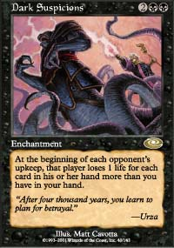
"Testing IBC a great situation came up that prompted a "first time". R-B-w Arena with Death Grasp vs Go-Mar. It was game 2 and I had resolved a sided-in Dark Suspicions early and had dealt all 16 damage to the Go-Mar player. I was at 4 life with no cards in hand, my opponent with 4 life, 1 card in hand and Dromar out. Go-Mar passed the turn, and I will die the next turn if I don't topdeck, and I do such, drawing a Death Grasp. I Death Grasp my opponent for 4, hoping it would end the game, but instead the player cast Fact or Fiction looking for the counter. The Fact or Fiction was as follows. Land-land-land-land-Undermine. I chose to divide the piles 5-0. If he took 0 he lost to the Grasp, if he took the 5 stack, he lost to the Suspicions since there would be 4 cards left in his hand. First time I've heard of a 5-0 split winning a game."

BAD PLAY OF THE WEEK - WORLD CHAMPIONSHIPS EDITION
Just because a player qualifies for Worlds does not mean he will play perfectly. Here are three excellent stories that were reported to me by concerned players and judges at Worlds.
Turbo-Flametongue (Reported by Gis H.)
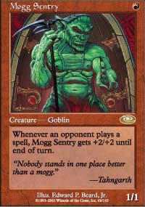
This play was seen on Day 1 (Standard) of Worlds. Player A lays a mountain and passes his turn. Player B lays a mountain, taps it, and casts Mogg Sentry. Player A lays a Swamp, casts Dark Ritual and summons Flametongue Kavu, targeting Sentry. The goblin, which just received +4/+4 due to an opponent casting two spells in a row, does not mind taking four points of damage that turn.
To Block or Not to Block (Reported by Mike Turian)
Player A attacks with Phyrexian Reaper. Player B chooses to block with Slingshot Goblin enchanted by Sinister Strength and Hobble. Player A points out that the block is illegal since Sinister Strength makes the Goblin black. Player B thinks some more, and decides to team-block a Reaper with Thornscape Falmiliar and Quirion Elves! Instead of dealing three to the Reaper, the two green creatures read the Reaper's special ability (unlike their controller) and promptly die.
For Love of Stompy (Reported by Josh Bennett)
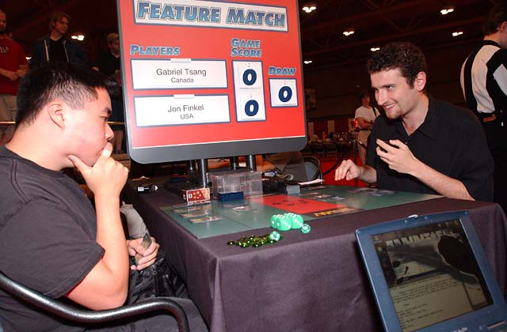
In a feature match, Canadian Gab Tsang was facing against a relative newcomer to the Pro Tour: Jon Finkel. Tsang was playing a Stompy deck. His Rogue Elephant was in a damage race against Masticore. Finkel was down to only one card in hand though, unable to play any more spells. Tsang was down to four life. He attacked with Rogue Elephant and cast Giant Growth on it for the win. Finkel cast Counterspell he just top-decked. As Tsang was at four life, he scooped his cards. "You know you shouldn't scoop there. The 'Core was going away on my upkeep," said Finkel. Demoralized Tsang proceeded to lose the match 1-2.
As always, please send good/bad plays, cool trivia questions, and other news to NEW ADDRESS: ashv80@hotmail.com.

